
Free Software: what is at stake ?

The concept of Free Software sends us back to the early 1980's. At the time, some researchers devoted both to the idea of collaboration in code development and to the culture of scientific publication (that was then the norm in computing) decided to legally secure their work and practices.
They wrote licenses cleverly using copyright laws, in order to share their software with all human beings while protecting them against any appropriation attempt. Eben Moglen, one of the redactor of the most popular Free Software license – the GNU GPL – often declared that his license allows “the creation of a common collection to which anybody can add and to which nobody can remove anything”. The other author, Richard Stallman, likes to remind us that Free Software can be defined by three words: “Liberty, Equality, Fraternity”.
In practice, since Free Software can be freely used, copied, modified and redistributed lawfully by anybody, it has been spreading a lot during the last twenty years and the number of contributors to the common collection such software constitutes is constantly increasing.
.
Today, the movement introduced by a few researchers has become a recognized phenomenon of society. Millions of users (individuals, NGOs, companies, administrations...) make use of the liberties that come with Free Software. A quality offer exists, thanks to the cooperation between these users over the Internet. They represent more and more a direct competitor for the dominant actors of proprietary computing, such as Microsoft.
Pieces of software such as the GNU/Linux operating system, the Firefox browser or the Open-Office suite are well-known examples of Free Softwares which, day after day, become more popular, and are commonly used in businesses and at home. In addition, the Internet's reliability is based on Free Software since its beginning, the same way the reliability of some stock-exchanges (BNP Paribas) and planes (Rafale, Airbus 380) is. Free Software can be found in electronic devices (such as domestic Internet gateways...) but also in ATMs, mobile phones or PDAs.

A societal issue
Free Software can be copied legally by anybody, it can almost always be downloaded from the Internet. This free of charge access, allows the less privileged populations to avoid resorting to illegal copying of software in order to benefit from technological progress. Free software is intrinsically a tool to reduce the “digital divide”
Since Free Software is shared with its source code, this code can be studied to understand the techniques it implements so they can be reused and transmitted, including outside of the usual training and educational fields. The way free software developers cooperate through the Internet simplifies the transfers of expertise beyond borders.
Free Software is not a merchandise and those who develop it are contributing to the transmission to many people of scientific knowledge, technical expertise and technologies allowing them to access to Knowledge. Moreover, he GNU project – a key project for Free Software – has been classified by UNESCO as a “World Treasure”.

An economic issue
Free Software allows the development of a dynamic economy referred to as “coopetition”, in which the actors share part of the R&D costs and compete on the services based on common generic blocks. In the US, in Europe, in Asia, a real service-oriented economy has been created around free software.
The companies from that sector make a living on the support, training, integration, consulting and on specialization of generic blocks. The organizations making use of such software adhere to its model for the quality offer, but also because Free Software confers them more independence and a better control over the costs of maintenance and internal development.
The number of companies using Free Software steadily increases and, everywhere in the world, vast sections of States' and local governments' information systems migrate to Free Software.

A strategic issue
Free Software is more and more seen by States and political leaders as:
- a way of enforcing sovereignty and industrial policies;
- a means to control public spendings;
- a means to achieve sustainable development.
Several projects illustrate this trend:
- the development of secured operating systems for military purposes (China, US, France ...);
- the political will to develop a national industry around Free Software (“Orient Ware” consortium between China and Europe, project of French “competitiveness area” around Free Software ...);
- the developments around electronic administrations (Free Software was made compulsory in Brazil and in the Netherlands, Internet income statement in France ...) and the migration of French members of parliament to a free operating system;
- the ever-growing use by developing countries (such as the actions led by the “University Agency for French-Speaking” [Agence Universitaire de la Francophonie] ...).
As a conclusion, here is a quote:
“The State services often use software whose source code isn't available, which prevents these States both from correcting the errors that the suppliers would refuse to correct themselves and from verifying the absence of security threats in sensitive pieces of software. Sometimes, without knowing it, the States' services use software which secretly transmits confidential information to foreign companies or bodies. But the economic model of the software and the telecommunication industries, pushed by the market, is mainly based on the appropriation of clients and the exponential exploitation of the users' profile. These economic models encourages strategies of incompatibility, industrial secrecy, programmed obsolescence and violations of individual freedom. If the French State, because of the communication networks being transnational, cannot claim to be able to eliminate by law such deep-seated deviations it can anyhow help the development in France of an information society respecting public liberties, consumer security and healthy competition, and hope to be regarded as a forerunner in Europe and in the world.” (excerpt of the reasons of a French law proposal made by PS members of parliament in 2000, followed up in 2002 by French UMP senators).

A few figures
- The total amount of decent quality free software is worth at least at least € 12,000 million. This represents at least 131,000 men.year, or an annual contribution of € 800 million euros, half of which comes from developers based in Europe. In terms of service, free software could represent up to 32% of the market of computing-related services in 2010. (“The impact of Free/Libre/Open Source Software on innovation and competitiveness of the European Union”, January 2007, available on the European commission's website)
- In France, in 2004, 80% of companies in the CAC40 [French Dow-Jones] and 56% of administrations and of local public governments were using Free Software (PAC, 2004). 67% of companies were using Free Software, 16% were considering to do so in 2005 and only 17% had no planned use whatsoever in the short term (InformationWeek, November 2004).
- In 2005, nearly 90% of companies were considering migrating their Windows Server to Linux in the upcoming year (InformationWeek, Research Brief “Linux Outlook”, February 2005) and 70% of all web servers in the world were free servers(Netcraft, November 2005 based on 74 572 794 web site).
- In France, in 2006, the French administration has spent 9% of it's computing budget on free software developments and free platforms, that is including the labor expenses, whereas it had spent only 6% in 2005. This represents 900 million euros and 15% of the total market of IT services for the French administration, with a 12% per annum growth expected during the next two years (Markess International, April 2006).
- In France, in 2007, the turnover of the Free Software industry reached € 730 million, which represents a 66% increase compared to 2006 (figures from Pierre Audoin Consultant).
- Here is the ratio of immigration/emigration of free software developers: France is by far the last though it is amongst the countries where student-engineers participate the most to Free Software projects (see ³).
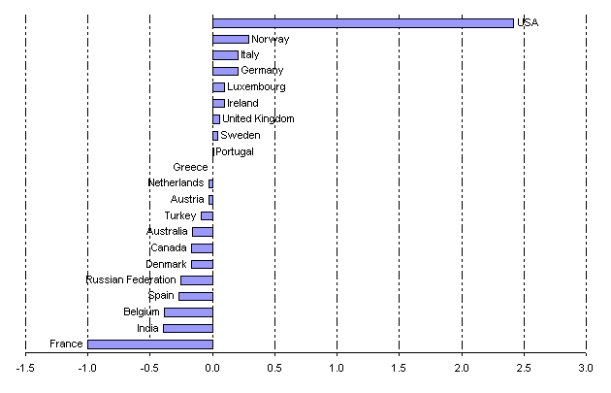

http://www.assemblee-nationale.fr/11/propositions/pion2437.asp
http://www.senat.fr/leg/ppl02-032.html
http://ec.europa.eu/enterprise/ict/policy/doc/2006-11-20-flossimpact.pdf

