
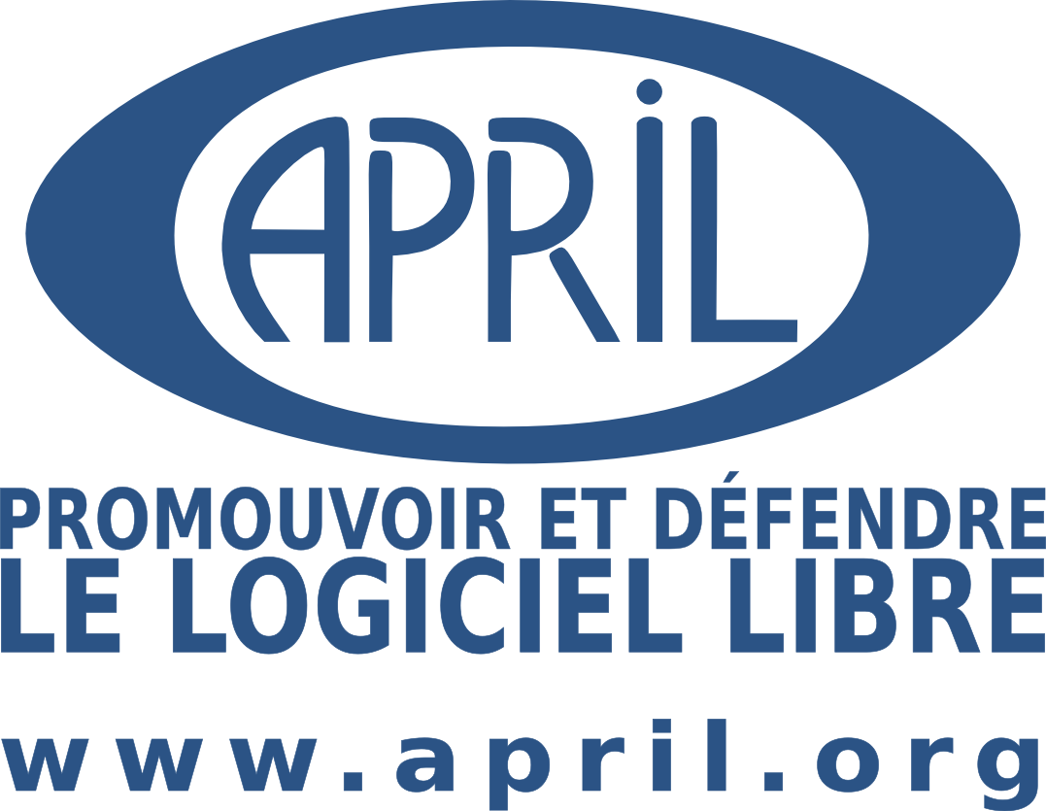
THE PACT
OF
FREE SOFTWARE
A common to protect and develop.

translation of a document that was submitted by candidats.fr,
an initiative led by April, for signature by the candidates to the parliamentary elections held in France in 2007.

521 candidates signed it.
69 out of the 577 elected members of the Parliament signed it.

I am aware that
The work of Free Software actors plays a role in the preservation of essential freedom in the digital era, the sharing of knowledge and the bridging of the "digital gap". It is also an opportunity for the general public, for our (the) technological independence and competitiveness, in France and in Europe.

Free Software is a "common", to be protected and developed. Its existence relies upon the right for an author to release their (his) software along with the source code, and to grant everyone the right to use, copy, adapt and redistribute it, in its original or in a modified form.

I therefore undertake to
Encourage all administrations, all public or local services to prefer Free Software and open standards in their choices, purchases and own developments.

Stand up for Free Software authors' and users' rights, especially by requiring the modification of any legal text currently weakening those rights, and opposing any legal project that would lead to such consequences.

