

Synthetic moral report 2008

Table of content
April in a nutshell 3
The year 2008 6
Main achievements 7
Press review 8
Raising awareness 8
Translation of the GNU philosophy 9
Unfair computing 9
Free association 9
Animation 10
Translation 11
Issues 12
Public policy 12
Digital forum 12
Candidats.fr 13
Companies & economy 13
Education 13
Bundled Selling (Racketiciel) 14
"Creation and Internet" bill (aka HADOPI) 15
Software patents 15
OOXML, standardization, the serial continuation 16
Digital solidarity fund 16
Digital voting 16
Digital administration 16
Others issues 17
Other actions 19
Open World Forum 19
Actions outside Paris 19
Conferences 19
Media 20
2009 – 2014 prospect 21
A rapid evolution 21
A "2009-2014" roadmap 21
Promotion and Free Software defense
Thematic lectures 22
April shall be what we all make from it 23

April in a nutshell
April is the French reference association for the promotion and the defence of Free Software. Since 1996, it is a major player of the democratization and the distribution of Free Software and open standards within the general public, professionals and institutions in the French-speaking community.
In the digital era that is ours, it also aims to inform the public on the dangers of an exclusive appropriation of information an knowledge by private interests.
April communicates with public authorities to defend Free Software and obtain favourable decisions
The goals of April:
- Promote Free Software within the general public, professionals, association and authorities.
- Raise awareness of the greater number regarding the stakes of open standards and interoperability.
- Obtain political, legal and regulatory decision in favour of the development of Free Software and of knowledge sharing.
- Facilitate the sharing of knowledge.
- Defending the rights of users and authors of Free Software.
April in a few figures:
- Over 12 years of action.
- Over 4000 individual members: users, experts, sympathizers...
- Over 300 structure members: corporations, associations, communities. university departments.
- A team of 3 full-time employees..
- Approximately 3 500 hours / year of voluntary work. .
- In two years, the number of members in April has been multiplied by eight.
- 30 % of members are in the greater Paris area and the other 70% are in the rest of France and abroad.
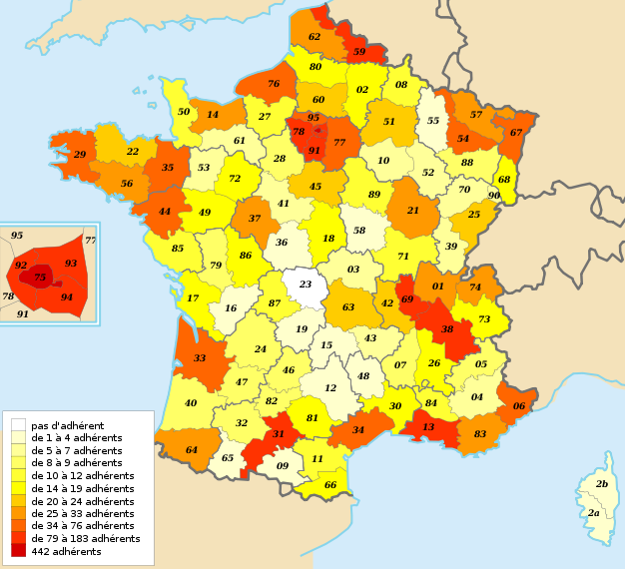Distribution of individual members across France

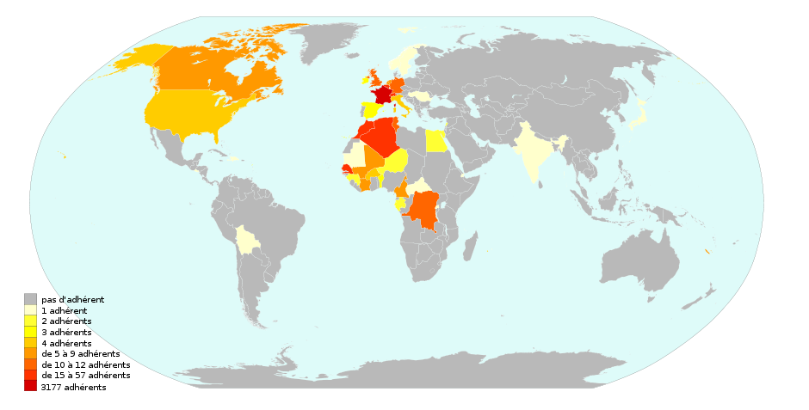Distribution of individual members across the world

The year 2008
From a internal point of view, 2008 was a year of significant change for the association:
- the team of three full-time employees is now entirely financed by April;
- the number of members has increased considerably, thanks mainly to the membership campaign started on November 12th, 2008. The "Île de France" region (greater Paris area) was the first regional public community to become member in January 2008, and recently the city of Yerres joined Pierrefitte-sur-Seine as member city. A new kind of membership appeared when two university departments (Colibre and Le2i) joined April;
- the association's visibility in the media (web, written press, radio or television) increased yet again, including in the non-specialized press;
- the institutional activity of the association increased very significantly. The newsletter presents regularly the meetings that have been held and the mail exchange on these subjects;
- the jury's special prize at the Lutèce d'Or 2008 award ceremony was given to the association, in recognition of its past and current work and as an encouragement to continue in 2009 and after;
- the association's campaign worked well: for instance, the Candidats.fr campaign was continued and so was the Free Association questionnaire (with over 350 answers) ;
- ...
The increase of the number of members also confirms the increase in importance of Free Software, as is testified by the "Attali report", which calls Free Software the "revolution that musn't be missed".
The vitality of the association is clear from the outside of the association, as demonstrate the relations with the media. The contacts with the journalists are still increasing, numerous interviews were made and we are now contacted on a regular basis to have information or our opinion. The association is seen as a reference to be consulted.
April strengthened this year again its status as a reference player in the French-speaking world of Free Software thanks to whole of its actions.
The year 2009 will be the opportunity for much more, with the continuation of the Candidats.fr campaign for the European elections, the analysis of the answers to the Free Association questionnaire, the examination of the "Creation and internet" bill (aka HADOPI) etc. ; obviously, the upcoming bills will require to continue the battle for digital freedom and to raise our representatives' awareness. The four dangers (bundled selling, software patents, unfaithful computing, DRM) are still there. This illustrates the value of a structure promoting and defending Free Software and whose means are fit for such important stakes.
Thanks to all members, especially the active ones, and to our full-time employees who make this possible and help keep alive our body!
You can find the full moral report (which is a hundred pages long) with all the useful links at the following address:
http://www.april.org/fr/rapport-moral-sur-lactivite-de-lapril-en-2008
You can also find our 2008 overview regarding Free Software and related topics:
http://www.april.org/en/overview-2008-regarding-free-software-and-related-topics

Main achievements
- Multiplication by two of the number of members, including companies, associations, local authorities and two university departments, which is a first-timer. As of March 15th 2009, April counts 4500 members, of which 209 companies, about 125 associations, 4 local authorities, 3 university departments and 1 university. This size increase allowed a strengthening of April's network of members and partners, especially regarding the meshing at the national level.
- The team of April's full-time employees includes: an executive director (since March 2005), a public affairs officer (since October 2006) and an executive assistant (since October 2007).
- Over 3,500 hours of voluntary work in 2008.
- April changed its website for Drupal, migrated its wiki to Mediawiki and changed its logo to follow the change of website.
- April participated to the plenary kickoff session of the Digital Forum on May 29th 2008; along with WWF, it was the only representative of the civil society to talk during this session, confirming its role as a reference player within the digital domain.
- Following this, April was received by the French Secretary of State for the Digital Economy, who kept for his report "Digital France 2012" some of April's proposals in favor of information and free choice for the consumer as one action against bundled selling.
- Kickoff of the LibreAssociation initiative and, in partnership with CPCA and the Foundation for Human Progress, of the poll on associations' knowledge and use of Free Software. Almost 400 answers were received over a period of 9 weeks.
- Reduction of the legal insecurity created by the DADVSI law: following the annulation request submitted by April on February 2007, the French State Council established that the exception for decompilation prevailed over the legal protection by DRM defined by the DADVSI law.
- Nearly 150 events in 18 regions for the 8th edition of the Free Festival.
- A partnership has been organized between April and the website Lolix, aiming on one hand to put forward the job offers from companies that are members of April and on the other hand to facilitate the hiring of candidates aware of Free technologies.
- Membership campaign
In order to promote and defend even better Free Software, April launched on November 12th 2008 a membership campaign with the aim to reinforce April's representativity and its means of action.
The goals are:
- finance our actions;
- employ new full-time employees;
- increase April's representativity and thus its influence when facing public authorities.
The campaign was annoucned by an interview of Benoît Sibaud, in the Libération newspaper on November 12th 2008 entitled "It's a philosophical issue" (page 24).
This campaign received many supports (Tristan Nitot, Ubuntu-fr, Videolan, Framasoft...) and the members have significantly relayed the campaign on their websites and their blogs (20% of new memberships come from personnalized membership forms).
Working groups
Part of the activity of the association rests on the notion of working groups. They are in charge of implementing the actions that can enter the object of the association. Some working groups are reserved to the members but most are open to non-members. The various working groups can be found on the following page: http://www.april.org/groupes

Press review
As part of its media monitoring, April publishes an online press review. A hundred "press review" articles were published in 2008. The press review is also published each week on LinuxFr.org.

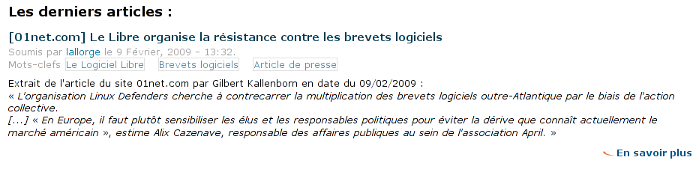
Raising awareness
To increase even more the awareness of the general public on Free Software and its stakes, April launched in 2007 a workgroup called “Raising awareness”. This workgroup is dedicated to inventory, to improve and to complete the supports of communication regarding Free Software.
A first phase consisting of an inventory allowed to produce a list of existing ressources: posters, flyers, articles, but also multimedia resources (animations, videos...).
During the 2008 Free Software Festival, April's workgroup Raising Awareness published in March 2008 a new version of ExpoLibre, a collection of informative billboards regarding Free Software, usable for instance by associations of Free Software users during public events.
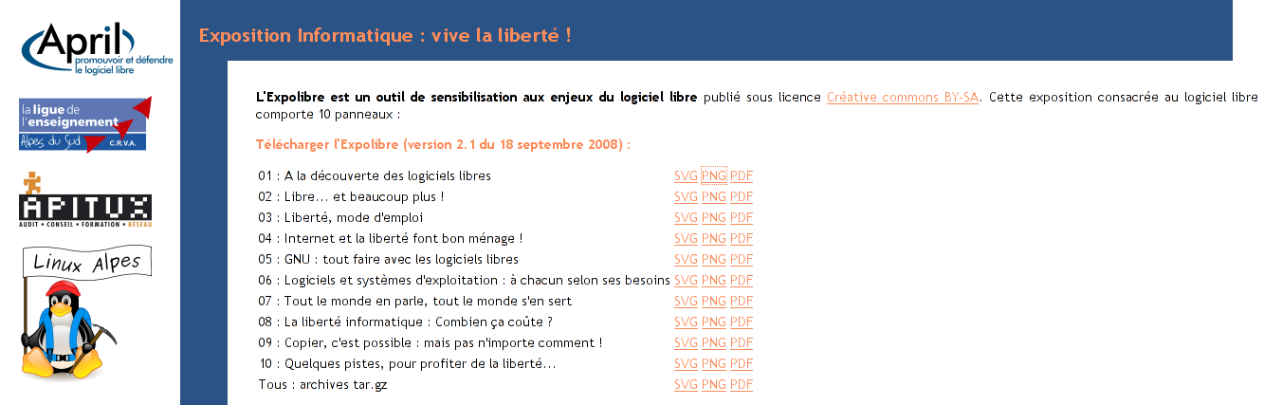

Translation of the GNU philosophy
The workgroup “Translation of the GNU philosophy” (created in 1997) has as a goal to make known to the French speaking public the ideas of the Free Software Foundation, which April shares in many points. Over two hundred translations are on-line on the http://www.gnu.org. The initial objective of the workgroup (i.e. the translation of the main documents of the gnu.org site) is nearly reached. The goals for 2009 are the translation of files within new directories and the continuation of the conversion of already translated documents to the new format used by the webmasters of gnu.org.

Unfair computing
The workgroup "Unfair Computing" follows the projects on so-colled “reliable computing” which is renamed “unfair computing” and their effects on personal freedoms and on the development of Free Software. These pieces of information allow to do the annual retrospective on unfair computing, in addition to inform April's members on these issues.

Free association
In association with the FPH (Foundation for the Progress of Humankind [Fondation pour le Progrès de l'Homme in French]), April launched in 2007 the project “Free association” which aims at raising awareness and at accompanying the associations towards Free Software.
The workgroup focused in 2008 on consolidating a network of structures (obviously, mainly associative ones according to the aim of this workgroup) likely to be interested, at one time or another, in Free Software or in disseminating information in their own networks. For this, group members relayed themselves to be present at different key-events for associations.

The notable action taken by the group this year remains, in partnership with CPCA,the survey aimed to better understand the customs and practices of French associations with respect to general computing and Free computing in particular. The idea is to better understand their needs in order to determine the tools to be developed or to be supported in the Free Software ecosystem. The number of answers nearing the 400 will undoubtedly be enough to get a first "snapshot" of practices and to publish, during the 1st quarter of 2009, an analysis of those responses. An observatory will allow, in the next months, to continue the gathering of informations.
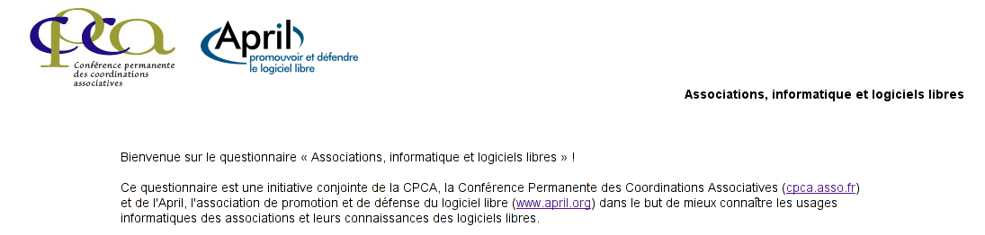
Free Software festival
April launched in 2001 the Free Software festival initiative, which consists in the coordination of events promoting Free Software on a nationwide scale, in a festive and friendly atmosphere. Every year, this initiative takes place around March 21st, to accompany the arrival of spring. For the second time, a collaboration with the Free Software Diary had been organized in 2008, this diary being used to list the events organized within the framework of the Free Software initiative.
During the 2008 edition, for the first time the Free Software Festival received the support of the French Delegation for the uses of the Internet (which depends of the French Secretary of State of Higher Education and Research).
Around 150 events (a +57% increase compared to 2007) were organized in 18 French regions by dozens of associations or bodies, including numerous events organized by public digital forums, another sign of the successful partnership with the French Delegation for the uses of the Internet.


Animation
Workgroup created in 2008 to work on the animation of the community of members of April. The association now has over 4,500 members (multiplication by eight of the figure in two years); this abrupt change of scale calls for a thorough thought on the organization of the community of members, in order to facilitate the implication of members in the realization of the association's goals. The first piece of work consisted in understanding the current processes, followed by the establishment of proposals and the writing of an action plan.

Translation
The purpose of the "Translation" workgroup is to translate into various languages April's website and various useful documents, mainly press releases. The workgroup translated amongst other things the awareness documents of Candidats.fr and the white paper on the economic models of Free Software.

Issues
A major and less visible part of the action of the association is the "advocacy", with numerous contacts within numerous groups (political, economic, ...).
April is part of various legal combats to defend the players of the Free Software world.

Public policy
April contributed to the thoughts on the implementation of a public policy promoting interoperability, open standards and Free Software.
Many appointments were obtained with all kinds of political leaders, whether they were members of parliament, members of ministries or members of local delegations.
On the legal level, April met members of parliament from all political parties with whom it shared its views on Free Software, bundled selling of hardware with software, DRMs, the French "Creation and Internet" (or HADOPI) bill, software patents, accessibility ...
On the governmental level, April met the new official in charge of the French Delegation on Internet's Uses, the Prime Minister's advisors on ICT, technical advisors from several ministries, the General Direction for Companies, the Regulation Authority of Technical Measures ...
During trips outside of the Paris region, April met members of parliament and executives (director of the Program for the Information Society of the city of Lyon, Agency for the Economic Development of the area of Lyon, "ICT - Interconnected" department of the Regional Agency for Development and Innovation, LYON INFOCITE - LYON GAME, "Digital city - Computing - ICT" advisor for the mayor of Lille, the Regional Department for Social Economy and Solidarity of the Alsace region...
Contacts were also held throughout the year with other structures working on common subjects with April, such as the consumer association UFC-Que Choisir.

Digital forum
April took part in the Digital Forum, organized at the French Republic President's request, each time April deemed it useful, it was in fact the only NGO along with WWF invited to participate to the kickoff of the Digital Forum. April also shared a written contribution that synthetically deals with the matters related to the legal framework, the State intervention and suggestions in order to strengthen Free Software in front of proprietary software.
In order to go more into the points raised in its written contribution, April met Éric Besson and two of his advisors to discuss more generally what Aprils wishes in terms of public policies related to Free Software.
At last, the "Digital France 2012" plan was unveiled by Éric Besson in October 2008. April had had the opportunity of consulting a draft version of the plan which left entirely aside Free Software, to which April replied through the media amongst other things. April welcomed in the plan's final version a better taking into account of Free Software, but also deplored some measures being vague and the French government's obstinacy about DRM.

Candidats.fr
April launched in early 2007 the "Candidats.fr" initiative which aims to make Free Software one of the topics of the election campaign. This initiative took successfully its place in the French presidential and parliamentary elections of 2007, and continued on during the election campaigns for town-halls and districts in 2008. Through the Candidats.fr initiative, April made available a tool to raise candidates' awareness regarding the stakes of Free Software and open standards: a specific documentation (a presentation of the specific Free Software issues for public authorities, a specific Free Software Pact and an online campaign tool). The site Candidats.fr also lists all those who signed the Free Software Pact.
In 2009 April shall extend this initiative to the European elections.

Companies & economy
In 2008, Free software raised from a development phase to an adoption one.
In 2008, April distributed during various events around 200 copies of its White Paper on the Economic Models of Free Software. Thanks to this publication, the association is invited on a regular basis to talk about these business models. April was also present at most of the business events related to Free Software. The year 2008 was also filled with institutional appointments regarding companies and Free Software, at all levels (from local level in different regions to ministry level). Our work is supported by an ever-growing number of legal entity members: 108 new company members in 2008.

Education
April's work regarding education is mainly constituted by its support and participation to associations that are specialized in that domain, such as OFSET or Scideralle. Still, April does lead specific actions in that area. For instance, April is one of the partners of the Master's course on Engineering of Free Software (I2L) at the Université du Littoral (ULCO, Calais).
April was auditioned by the members of the E-educ mission. This mission had been given by Xavier Darcos, French Minister for Education, to Syntec informatique, to work on the development of Information and Communication Technologies within the educational domain. April also published an analysis of the mission's report.
April attended the Educatice 2008 convention, as part of the SCEREN's village of Free Software excellence. A meeting was held with Catherine Gabay, advisor on digital technologies, edition and multimedia within the cabinet of Xavier Darcos. This meeting was set to talk about the use of Free Software within public education, especially having in mind the B2i program (Computing and Internet Degree) and BECTA's report translated by Framasoft and more generally the need for diversity and neutrality when teaching computing.

Bundled Selling (Racketiciel)
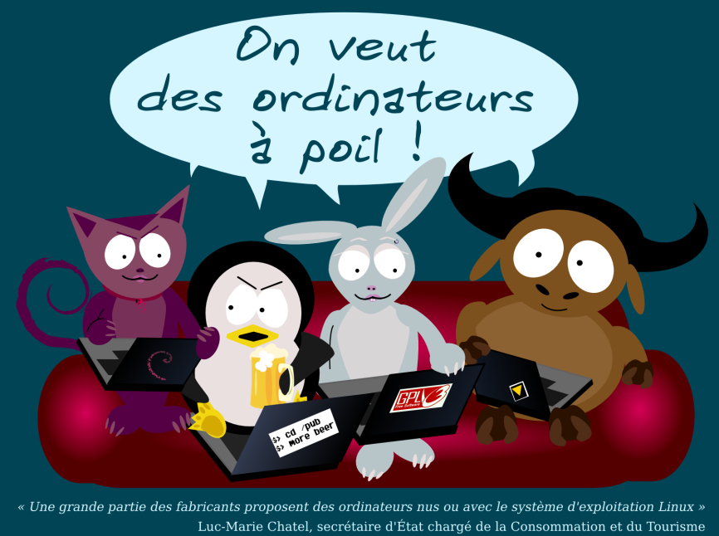

April is very much involved in the topic of bundled selling, along with Aful, Racketiciel and the consumer defence associations, such as UFC-Que Choisir and CLCV. The goal is to put an end to the ongoing scandal of bundled selling, in order to give back to customers their freedom to choose and allow to create a free market in the field of software for the general public, especially when it comes to operating systems.
In June 2008, the topics of bundled selling and class actions were included in the debates of the bill on the modernization of the economy. Members of Parliament from various political groups submitted amendments regarding bundled selling of computer hardware and software and regarding class actions.
Having been engaged for many years against bundled selling and wishing that a system of class actions be included in French law, April has invited Members of Parliament to support these various amendments.
The court decision in the first trial that UFC-Que Choisir issued against Darty was released on June 24th 2008. In a press release, April welcomed Darty's condemnation for not complying with the French consumption code and published an analysis of the judgment.
The closing meeting for the cycle of discussions of DGCCRF on bundled selling of hardware with software was held on July 3rd 2008. Consumer representatives, authors and users of Free Software (including April), vendors and distributors attended this meeting.
Despite several declarations from politicians (Luc Chatel, Éric Besson) and commitments against bundled selling included within the Digital France 2012 plan, the situation didn't progress significantly.
During each institutional meeting this topic was mentioned, and April was regularly in contact with the press. In 2009, April shall follow this topic with great attention and especially the commitments of the Digital France 2012 plan.
DRM: the French State Council re-instated the bypassing of DRM to gain interoperability
On February 21st 2007, April submitted to the French State Council a cancellation request against the decree signed on December 23rd 2006 "regarding legal repression against some copyright infringements or similar infringements". The State Council issued its decision on July 16th 2008 regarding this cancellation request. April published an analysis of this decision.
April welcomed this decision which practically re-instated the bypassing of DRM when done to obtain interoperability. In a very controversial decision, the French Constitutional Council had previously removed this possibility.

"Creation and Internet" bill (aka HADOPI)
From the time it had been aware of the preliminary bill, April had multiplied contacts especially with the offices of the Prime Minister (ICT advisor) and of the Ministry for Culture (ICT advisor and legal advisor). April also met senators as part of the preparation of the Hadopi bill. The association worked on one hand on the aspects underlying the "means of securization of one's connection", which could induce discrimination against Free Software users, and on the other hand on the legal protection of DRM and the so-called "Vivendi" amendments added to the disparaged DADVSI law. For this, April was in regular contact with consumer defence associations (UFC-Que Choisir...). April was one of the first to sign the petition launched by the magazine SVM against the "Olivennes" preliminary bill. April also supports La Quadrature du Net. La Quadrature du Net is a group of French citizens who inform the general public on proposed bills that would jeopardize civil freedom and the economic and social development of the digital age.
April actively participated in the preparation of the parliamentary debates and created a portal on this issue: http://www.april.org/hadopi.

Software patents
2008 was a statu quo year. The European negotiations on the unification project of courts concerned by disputes on patents (inducing the threat of software patents legalization) didn't succeed, despite France's efforts. April followed closely these debates and met institutional counterparts (French Secretary of State in charge of European Affairs...).
A coalition of over 80 computing companies, associations and developers declared the 24th of September as the "World day against software patents". April supported and communicated on this initiative. Notably, the association organized a conference entitled "Software Patents: current battles" during the Paris Capitale du Libre forum, in order to describe the current situation in the United States and in Europe.
In 2009, April shall remain aware about the progress of this project.

OOXML, standardization, the continuation of the serial
The debate on the standardization of revisable documents formats (Office formats) continued throughout 2008 and was temporarily concluded by the normalization of Office Open XML (OOXML, or ECMA-376). This normalization highlighted Microsoft's determination to fight on all fronts to defend its dominant position on office software, to counter Open Document. As a member of AFNOR's "Revisable documents' formats" commission, April denounced the various irregularities in the procedure and the tendentious relationship between the French State and Microsoft. April's Executive Director was interviewed by Groklaw on this very topic: "The AFNOR affair: Interview of Frédéric Couchet from April on OOXML in France".
April shall remain vigilant in 2009 on this matter, both on the European level and on the French level with the General Referential on Interoperability.

Digital solidarity fund
The Digital Solidarity Fund is a worldwide foundation aiming at reducing the digital gap between people. April participated to the "Summer Digital University of Tunisia", to the Lyon conference and to the strategic council for the plan of reconditioning PCs called "Computer 2.0".
Accessibility
April contributed to the the Internet's Rights Forum workgroups on sustainable development of the Internet. These contributions studied the matters of digital accessibility of websites. April signed and supported the web-for-all petition asking for the publication of the application decree for the French law on equal chances, which should specify the details to get to digital accessibility. April along with the creators of the petition met the French Prime Minister's advisor on information technologies to exchange on the digital accessibility of public services.

Digital voting
Although the subject of electronic voting is not directly the core of the object of the association (promoting and defending free software), the April took position when free software was concerned, and because of the democratic issue introduced by the voting computers. As a member of the Internet's Rights Forum, April has taken part in the workgroups "digital voting and modernization of the election processes". April put online its position on digital voting and announced it would retire from this workgroup.

Digital administration
April supported over the year all actions aiming at developing the use of the standardized open format Open Document within the French administration, and underlined its advantages whenever this was possible. The association asked several times for a quick publication of the decree instating the General Referential on Interoperability. In order to contribute to the implementation of this referential within local public administration, April met the association of Large French Cities (AMGVF) in order to study how informing large cities (especially mayors and CIOs) on the topic of Free Software and open standards.
The topic of digital administration and interoperability was at the heart of the Candidats.fr campaign during the election campaigns for town-halls and districts in 2008. Alongside representatives of DGME, April also took part in a day of work with the association of Large French Cities (AMGVF). This was an opportunity to exchange with CIOs of large cities on the issue of interoperability and digital administration, as well as on the constraints and specific goals of each individual city.

Other issues
The association took part over 2008 in other topics, including:
- ACTA / ACAC (Anti-Counterfeiting Trade Agreement), a anti-counterfeiting agreement, following such treaties as OMPI, EUCD or DADVSI, which was negotiated in the utmost secrecy. April wrote to the members of parliament involved in this to alert them and ask them to demand the publication of the ACTA work documents.
- April follows actively all topics related to monopolistic positions, especially concerning Microsoft. Such monopolies are harmful to Free Software and interoperability. April issued a press release following Microsoft's announcement of a new strategy regarding "interoperability". This new strategy continues to exclude the Free Software world from accessing the formats and protocols used in Microsoft software. Our communication was thoroughly quoted by the press, including articles in the paper versions of Le Monde and Libération and AFP information.
- April communicated on its answer to the consultation issued by the European Commission about online creative contents (recalling of our founding principles regarding DRM, interoperability, etc.).
- April also supported the petition "Open Parliament" asking that the European Parliament takes on open standards and promotes interoperability in the field of Information and Communication Technologies. April was invited to participate to the conference "Locked in" that was held at the European Parliament under the patronage of ecologist members of European parliament Eva Lichtenberger (Austria) and David Hammerstein (Spain).
- April called to support the declaration asking for the migration of the European Parliament to Free Software, and took its part in introducing European members of parliament on the subject.
- April is one of the partners of the governmental portal on computer security.
- April published its yearly overview regarding Free Software and related topics.
- Benoît Sibaud, April's president, wrote the second chapter entitled "Free Software and open formats for citizen accessibility" of the book "Democracy in our digital society".
- April met in several instances police representatives in charge of fighting counterfeiting, especially to give them a better grasp of the the legal principles underlying Free licenses.
- Within the discussion on the Telecom Package within the European Parliament, April took part in the information on the dangers regarding the so-called "trusted computing". It supported and took part in the Quadrature du Net action, which aimed at fighting discriminatory amendments (hidden establishing of so-called "trusted" computing, content and application filtering...).

Other actions
April took part in other action, including:

Open World Forum
April was an organizing member of the first edition of the Open World Forum that was held in Paris at the beginning of December 2008. The goals of the OWF are:
- open a forum to present, to a public as large as possible, influent and international as possible, the challenges and opportunities facing Free Software;
- allow various players of the Free Software domain to build recommendation for public decision-makers and other key-players, through its "2020 FLOSS Roadmap".
April is a member of the pilot comittee and of the program comittee of the OWF. Amongst other things, Alix Cazenave, April's Public Affairs Officer, headed the theme "public policies" and made a very significant contribution to the redaction of the first version of the "2020 FLOSS Roadmap".

Actions outside of Paris
April organized trips in different French regions for its representatives in order to meet different professional players, associations and other Free Software institutions, as well as local press. These trips were organized with the active support of Local User Groups.
In 2008, such trips were made to Rennes, Nantes, Lyon, Lille, Strasbourg and Saint-Étienne.
New trips are planned for 2009 in other regions.

Conferences
April gave a total of almost 50 conferences in 2008 in a wide variety of places and to vary different audiences: associations, professionals, universities, engineering schools, conventions, "Free days", public communities, public libraries...
April was also present at the main national and international events related to Free Software.
The association regularly holds a stall in different events. These stalls are a unique opportunity to meet the general public, to share documentation, or to sell t-shirts.

Media
April is established as a reference to be consulted by the press (journalists as well as press agencies such as AFP).
We can notice a significant increase in the association's visibility in the non-specialized media, for example through both radio shows on France Inter or through a TV interview on the TV channel France 2.
Journalists ask very often for April's opinion in comparison with that of associations such as Afdel or Renaissance Numérique .
Several interviews with the regional daily press were published, including Nord Éclair, Presse Océan, Ouest France and Le Progrès de Lyon.
We are now contacted by journalists simply to have information or our opinion.
The association had broadcasted two dozens press releases and these were largely quoted and/or used by the press.

2009 – 2014 prospect

A rapid evolution
In five years the association considerably evolved, multiplying the number of its members by twenty, and winning in the same time more diverse members. This diversity includes diversity amongst the physical members, but also amongst the legal bodies that are members, including the arrival of new kinds of members such as public communities, university departments and even the first university in 2009.
The association also evolved by employing its first full-time employees, by increasing dramatically its visibility and by strengthening its activity in an unforeseen way — this year's moral report has over a hundred pages! We have all the reasons to be proud of this evolution, especially since it has been done while staying faithful to the mission of the association: the promotion, democratization, diffusion and protection of Free Software.
Both the devotion, merits and imagination of the members, as well as the implication and the quality work of our team of employees must be thanked for it.

A "2009-2014" roadmap
The upcoming years will need us to be even more demanding and the outcome of the ongoing combats shall be determined by our capacity to mobilize, act and adapt. For this, April sets its ambition and its thoughts in line for a new step of development and actions through a "2009-2014" roadmap.
April's priority remains to promote Free Software, raise the awareness of the greater number regarding the stakes of open standards and interoperability and publicly defend Free Software politically and legally. Free Software will not be capable of developing unless with favourable political and legal environments. Thanks to its members and its team of employees, April's actions is precious and unique for all those who produce and/or use Free Software.
The world is currently going through a profound change. In 5 to 10 years, few will still doubt that cooperation and knowledge sharing are socially, politically and economically preferable to doctrine-based selfishness, restriction of usage rights, forcing on users of a unique model... But until then, different lobbies that don't understand or that don't want to follow this change - shall still be present and will need to be opposed.
To accompany this movement and accelerate it, April actively participates to create a collective conscience regarding the value of goods and informational public resources, first of which is Free Software.

Promotion and defense of Free Software
April chose to stay vigilant, to intensify and multiply the actions around promotion and defence that it has been leading for the last dozen years. These actions have made its reputation and have led to an increasing number of memberships, whether individuals, economic players, industrial players and associations of any size.
On one hand, April shall do its best to inform governments and parliaments, to show them that Free Software, interoperability, open formats and common informational goods are all strengths for the country and Europe, for citizens and the industries that they need to promote.
On the other hand, it shall be even more vigilant in order to denounce any additional attack against Free Software and digital freedoms, to prevent them whenever it is possible and to guarantee the security of Free Software development.
By 2014, April should reach 10,000 or even 15,000 members and a team of half a dozen employees, reinforcing its influence towards public administrations and its means of action. This shall be made possible by the fact that the memberships represent the major source of financing for the association.

Thematic lectures
April's evolution shall also be done through a broader opening to matters outside of France within the French speaking world and by a reinforced presence at the European level, both to better follow the activity at the European level and improve the communication with associations and NGOs from other countries when it comes to our work topics or neighboring topics.
In the short term, 2009 shall see the continuation of the Candidats.fr campaign during the European elections and of actions against the threats that are algorithm patenting, DRM, bundled selling, unfair computing, as well as the promotion of Free Software.
In the longer term, the activity of the association shall be driven by several topics that were identified as key:
- The four dangers (algorithm patenting, DRM, bundled selling, unfair computing) ;
- Open formats and interoperability ;
- Raising awareness of new audiences;
- Public education;
- Companies & economy
- International cooperation especially within the French-speaking community;
- Public administration and Free Software;
- Handicap and accessibility
The association shall continue its scrutiny of other topics, including:
- Free infrastructures;
- Democracy and transparency;
- Digital solidarity;
- International legislation;
- Licenses;
- 100 % Free systems (Free BIOS, firmware...) ;
- Online services;
- Scientific research;
- Digital solidarity / North-South cooperation;
- Methods and tools of Free Software.

April shall be what we all make from it
The goal of April is to establish a structure promoting and defending Free Software whose means are fit for such important stakes. In order to achieve this, April needs your support.
Becoming a member of April doesn't require you to become an active member of the association. But strong of its thousands of members, April shall be heard much better by the citizens' elected representatives, the government and the economic and social decision-makers. Thanks to your memberships and your gifts, it shall be capable of financing its employees and recruit the new employees that are required for the increasingly complex actions and topics it deals with.

Join us right now: http://www.april.org/adherer

More information on the project: http://libreassociation.info/.
See April's analysis : http://www.april.org/groupes/dadvsi/analyse-arret-conseil-etat-decret-dadvsi.html
http://www.lolix.org
Permanent conference of associative coordinations - the CPCA unites 16 coordinations of associations, representing about 500,000 associations in France
Secretary of State in charge of Prospective, of Evaluating Public Policies and of Digital Economy
http://www.groklaw.net/article.php?story=20080419005201783#french
http://www.securite-informatique.gouv.fr/.
http://www.april.org/en/overview-2008-regarding-free-software-and-related-topics
http://www.april.org/files/OWF_2020_Roadmap%20v2.18-3.pdf
"Service public" and "Le téléphone sonne" radio shows.

